MONITORING RESULTS

2020-2021 Operating Season

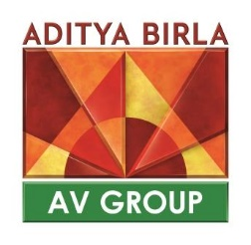

Non-Native Species Containment:
Since beginning the assessment programs AVG has only assessed the spread of alien species. There are 3 Japanese Larch (Larix kaempferi) plantations on the Freehold lands. Transect lines are done starting 50 meters outside the plantations ending 50 meters in the block. These assess seeding and sprouting or any other means or propagation of the Larch. This will be completed every 5 years, or until the plantations are harvested. The results from this year’s 30 plots showed that the Japanese Larch was not seeding or propagating in any way.

Herbicide:
The next monitoring program to report on will be negative impacts of herbicide. No blocks were treated in 2020, and only one block was treated in 2021. The assessment of this area will be completed in 2022 and reported on then.

